
Creating or accessing your leisure hub account:
Search for Active Wirral: Leisure Hub - Active Wirral
If you are already registered and have access, enter your email address and password
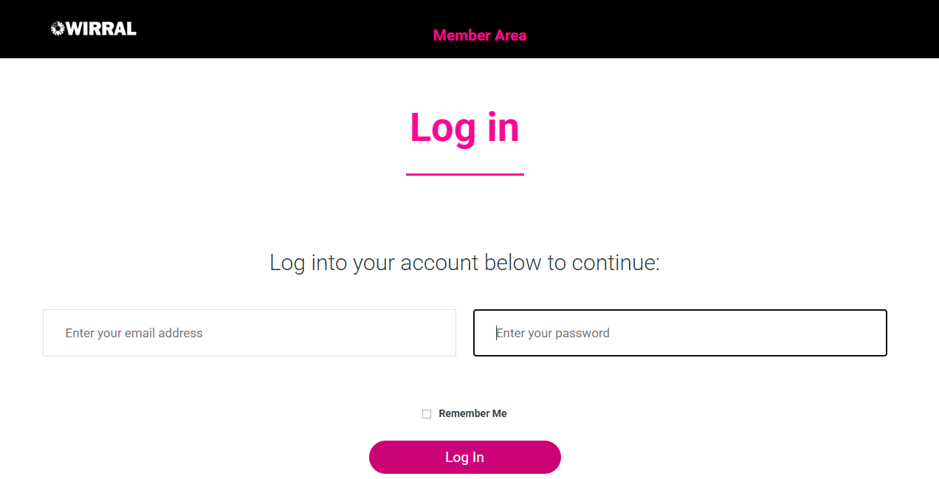
If you are registered, please select I am a member but need to create an account
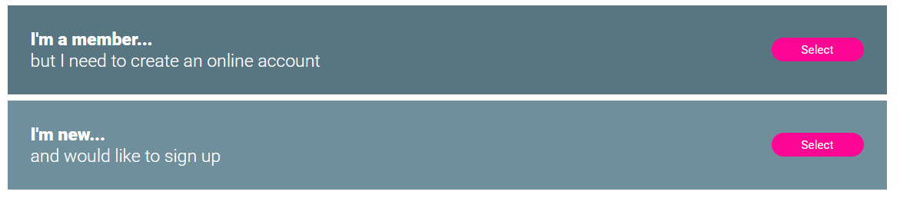
If you are completely, new please select I’m new and would like to sign up

You will then be able to login, you name will display and the option tabs below:
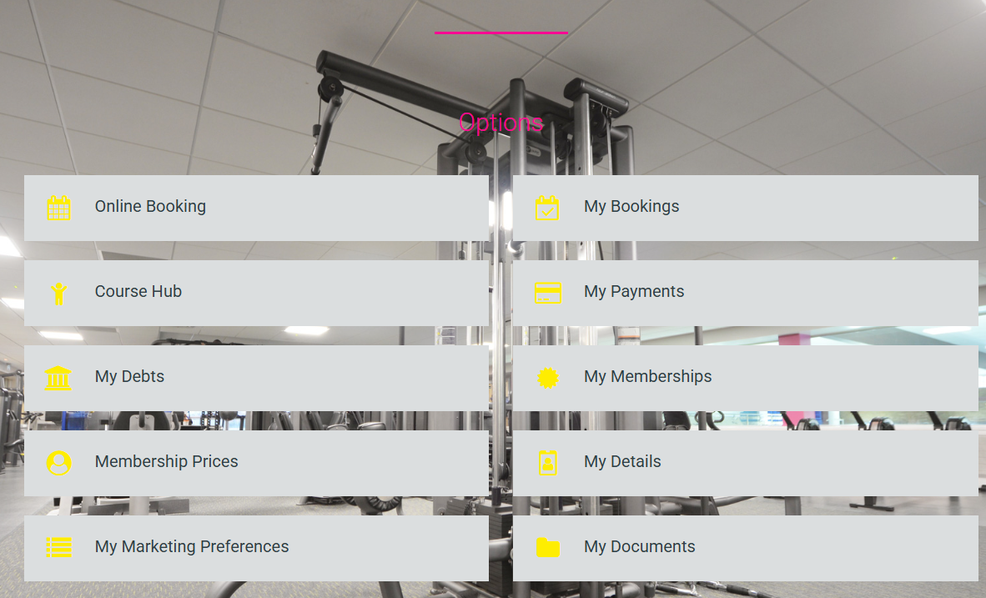
To access Course Hub, please select the tab
You will then be taken to Home Portal, where you can book, pay and set up swimming lessons, make payments and movements:
